**NODE SERVER EXAMPLE**

In this Project we will implement a simple Node Server. Let’s get started!

1.

Create a file with name server.js. Import Node.js core module first.

2.

Create web server (within function) and assign it to a variable server

3.

Inside createServer function, write a message to the DOM.

4.

At the end of the page, listen server for any incoming requests.

5.

Console a message for server running port.

Run your server with “node server.js” and open your browser on runnig port.

localhost:5000

6.

Inside createServer function, change your DOM message with an if else statement to write simple messages to the DOM according to the url.

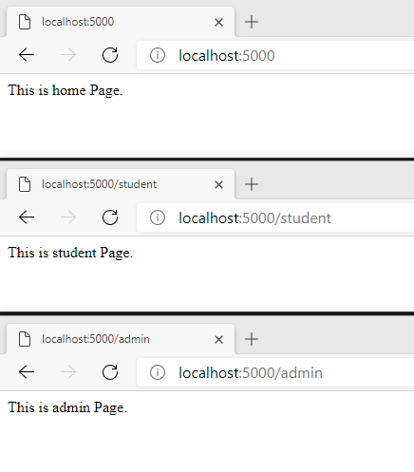

7.

Inside createServer function, add another url for sending a json response

So, this way you can create a simple web server that serves different responses.

**HINT:**

In this example, req.url is used to check the url of the current request and based on that it sends the response. To send a response, first it sets the response header using writeHead() method and then writes a string as a response body using write() method. Finally, Node.js web server sends the response using end() method